**Assignment - 1 :**

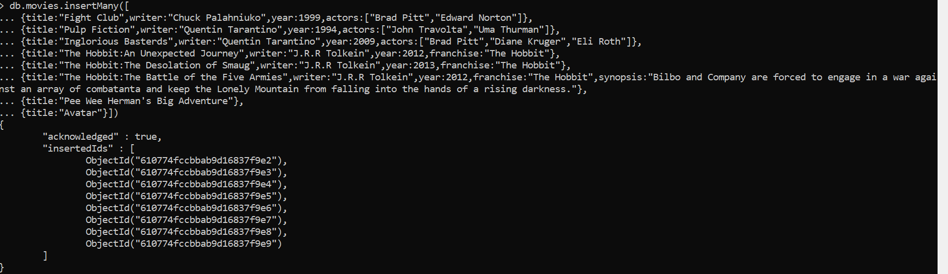

## **Query / Find Documents**

1)

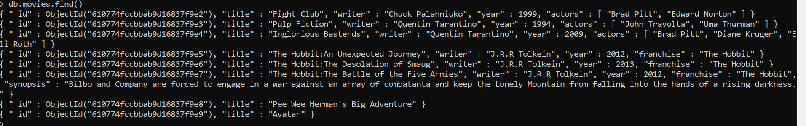

2)



3)



4)



5)



6)

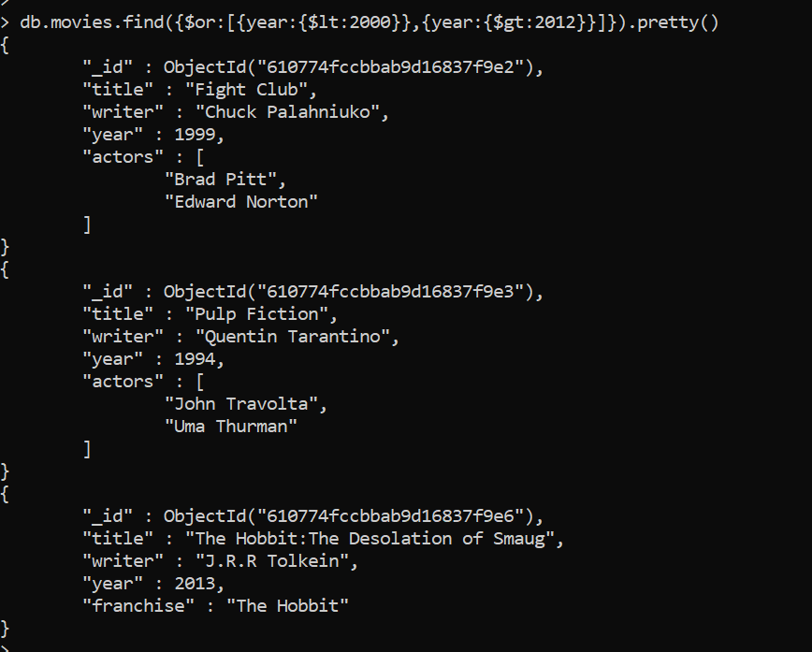

## **Update Documents**

1)

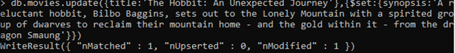

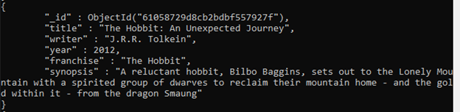

2)

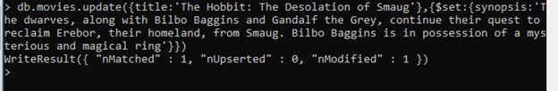

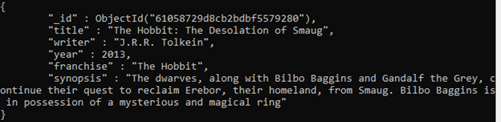

3)



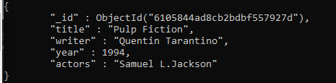

## **Text Search**

1)

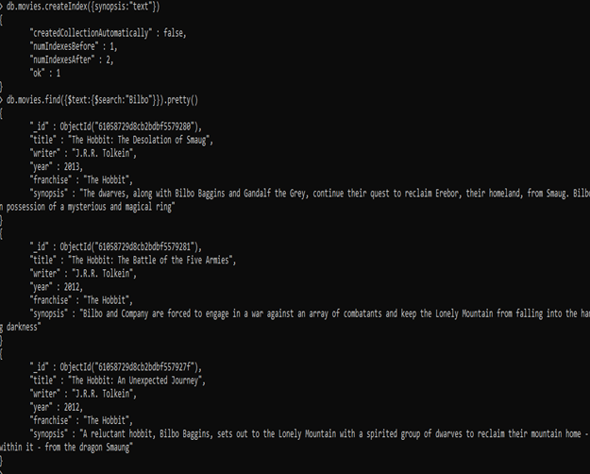

2)

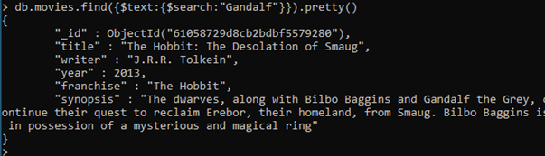

3)

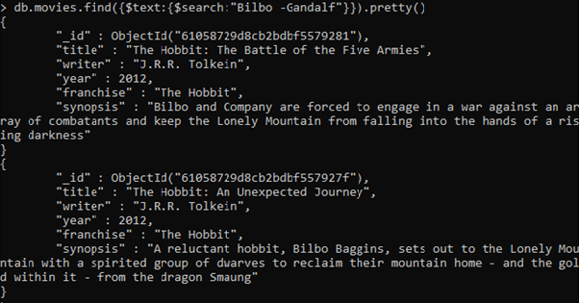

4)

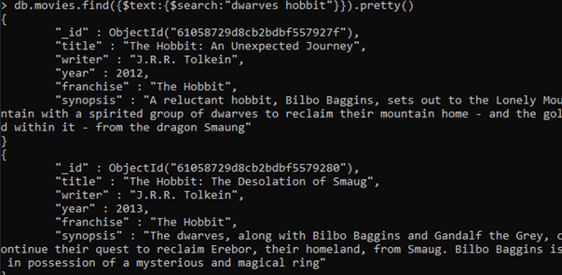

5)

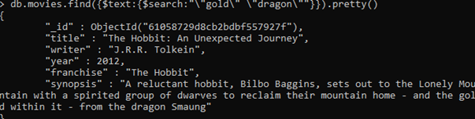

## **Delete Documents**

1)



2)



## **Relationships**

### **Insert the following documents into a users collection**

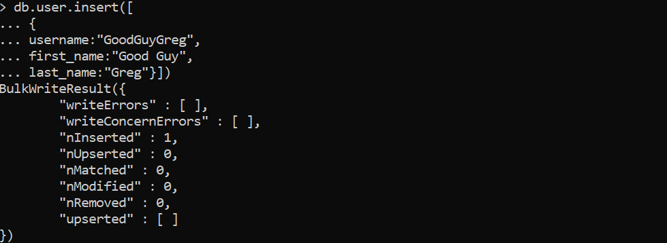

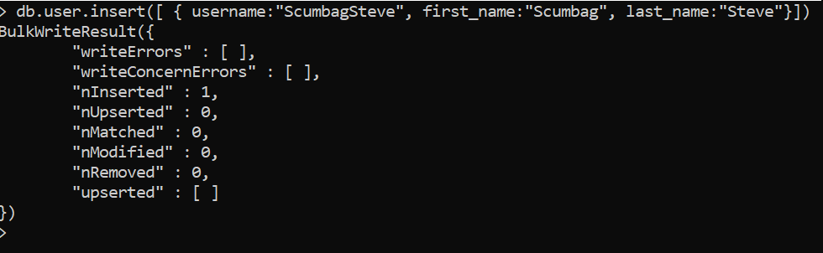

### **Insert the following documents into a posts collection**

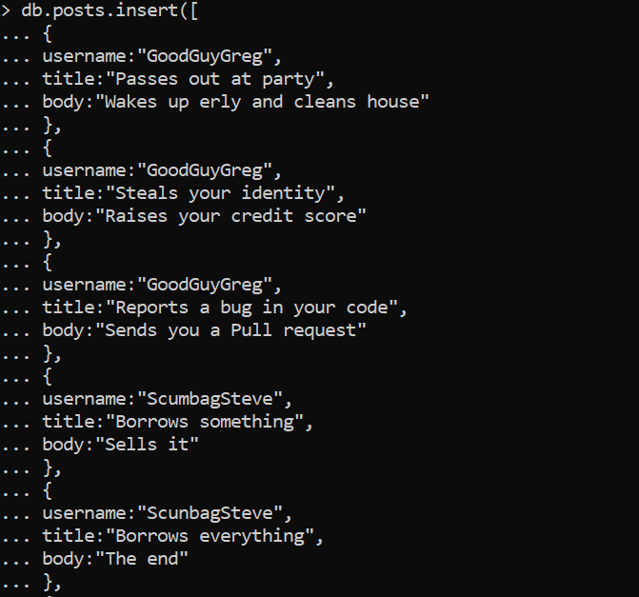

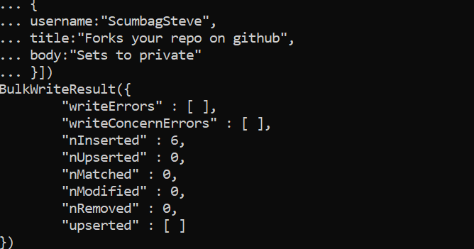

### **Insert the following documents into a comments collection**

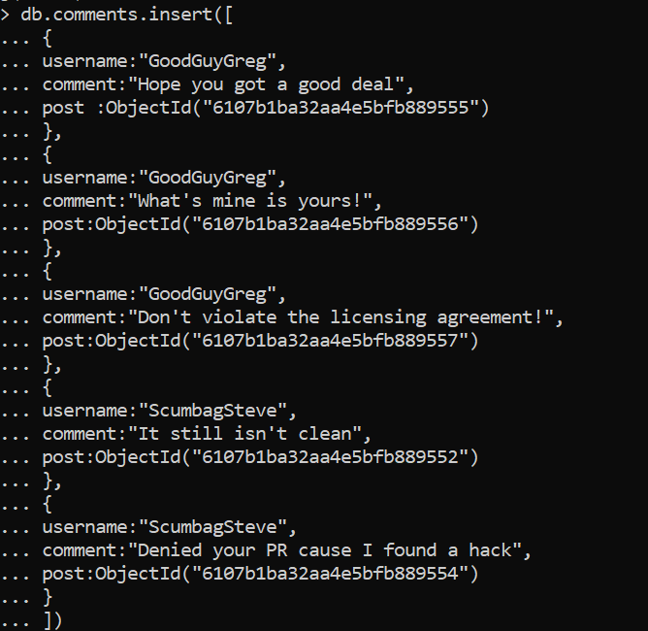

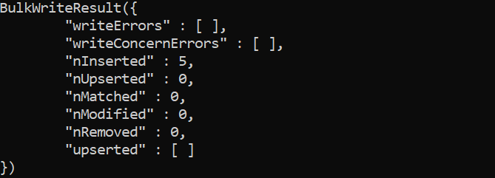

## **Querying related collections**

1)

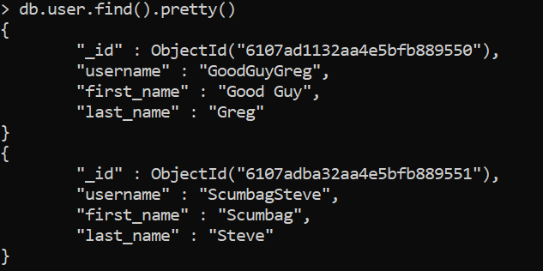

2)

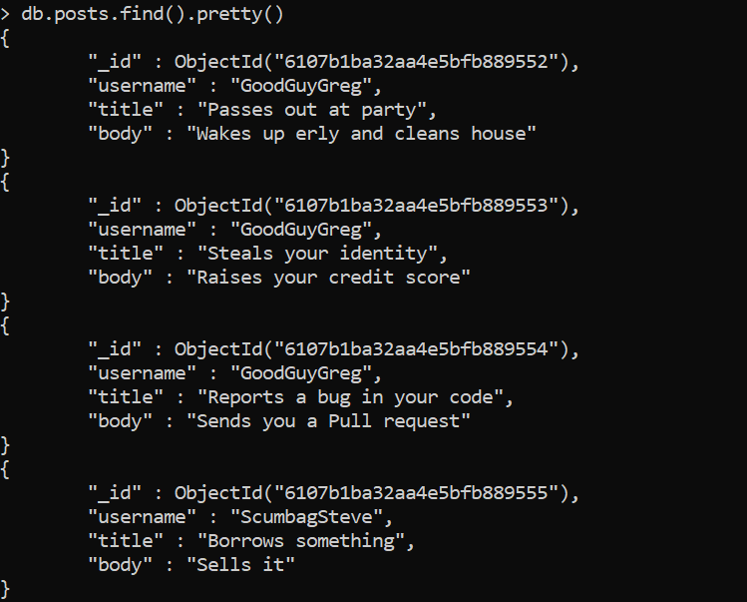

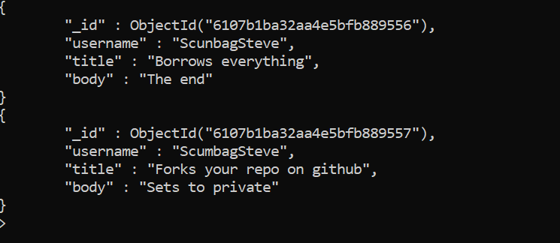

3)



4)



5)

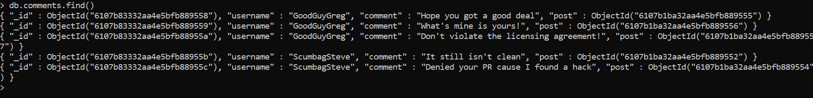

6)



7)



8)



ASSIGNMENT 2

1)

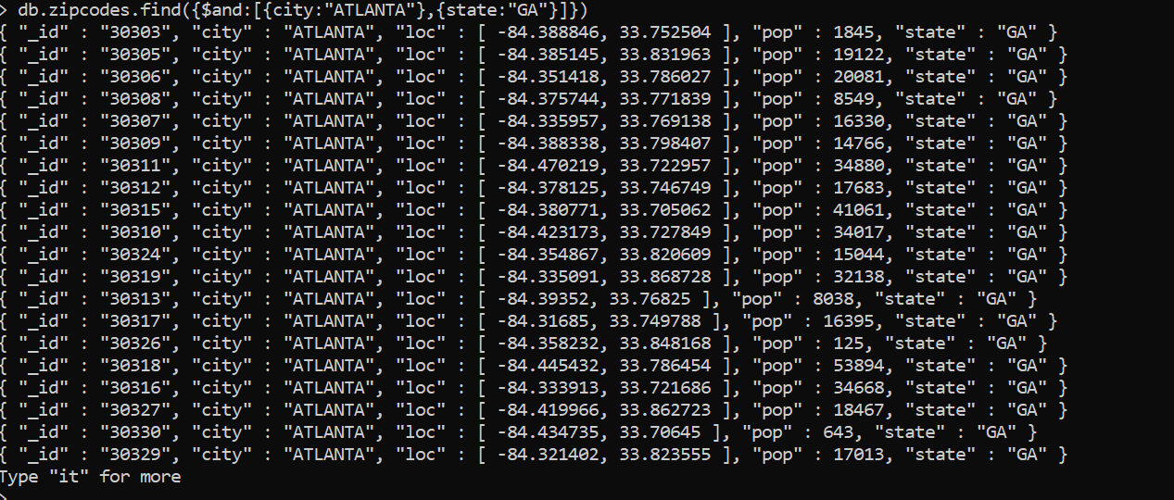

2)

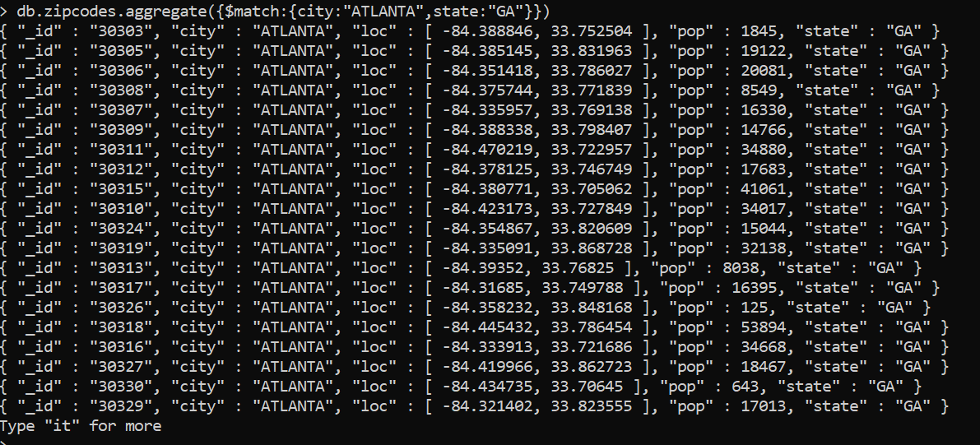

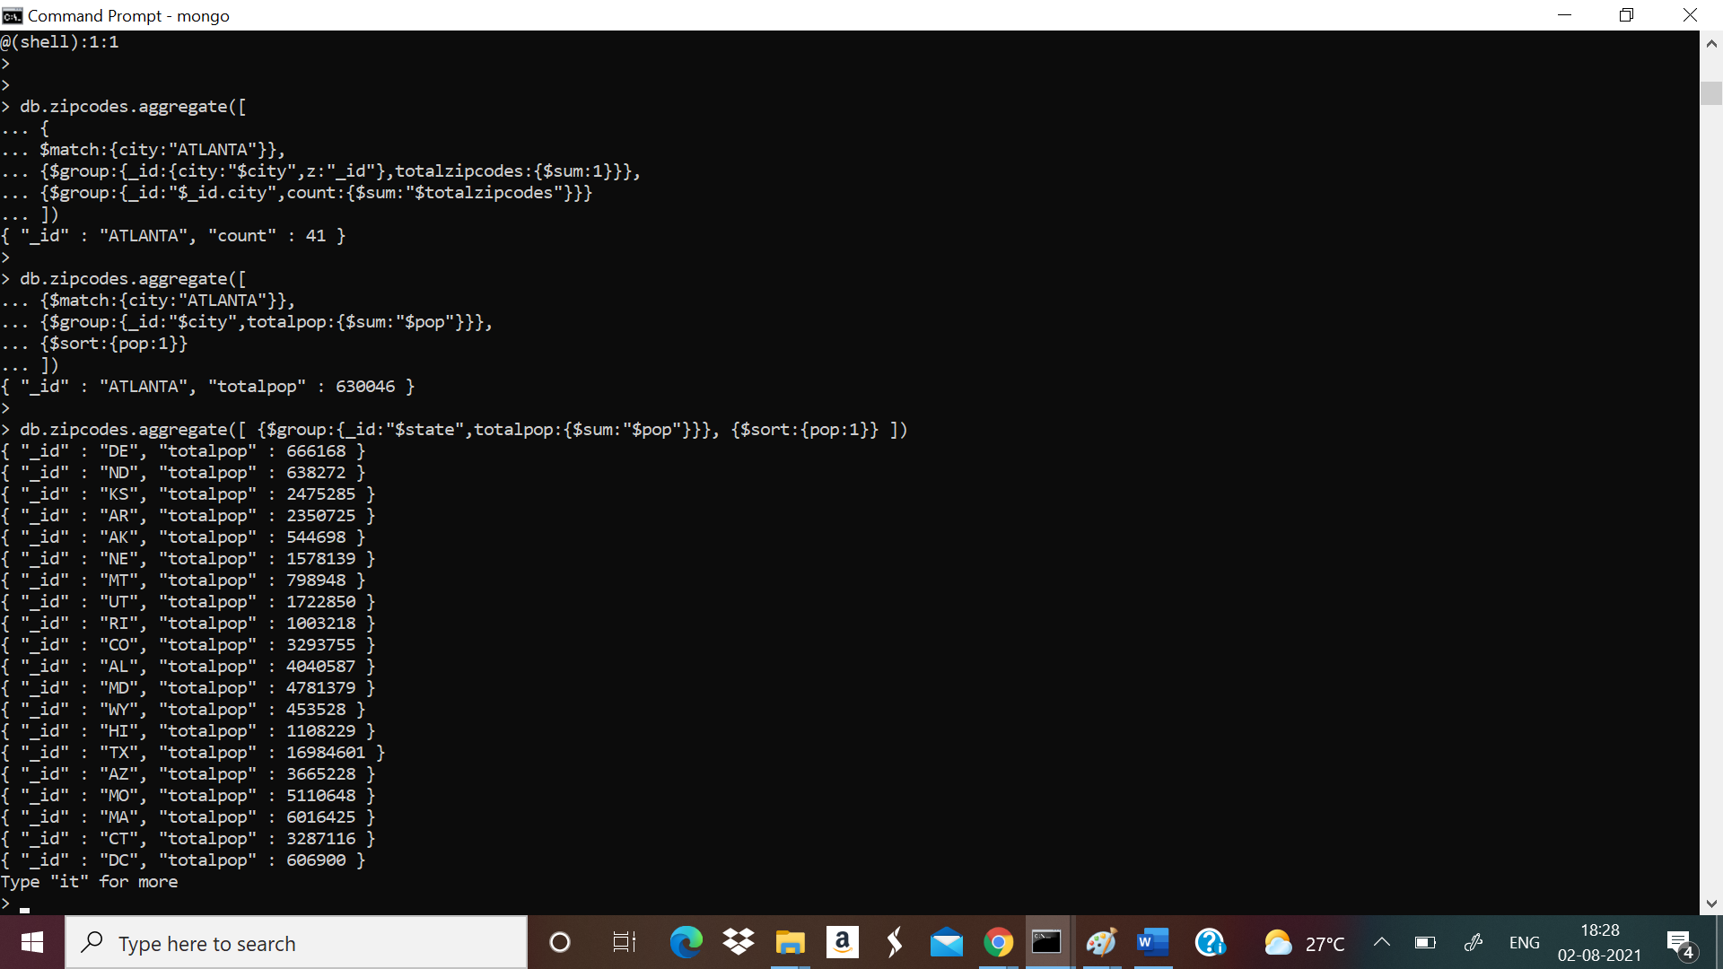

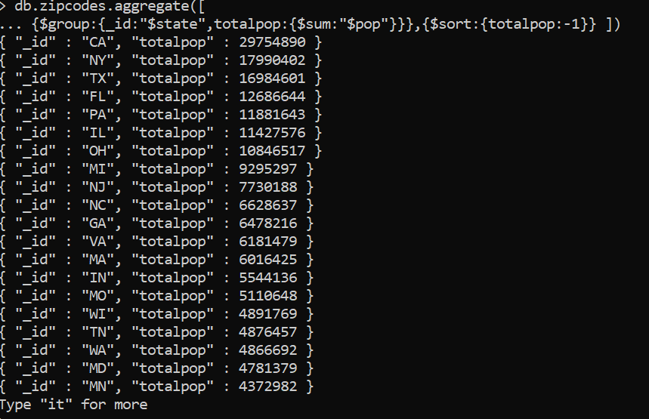

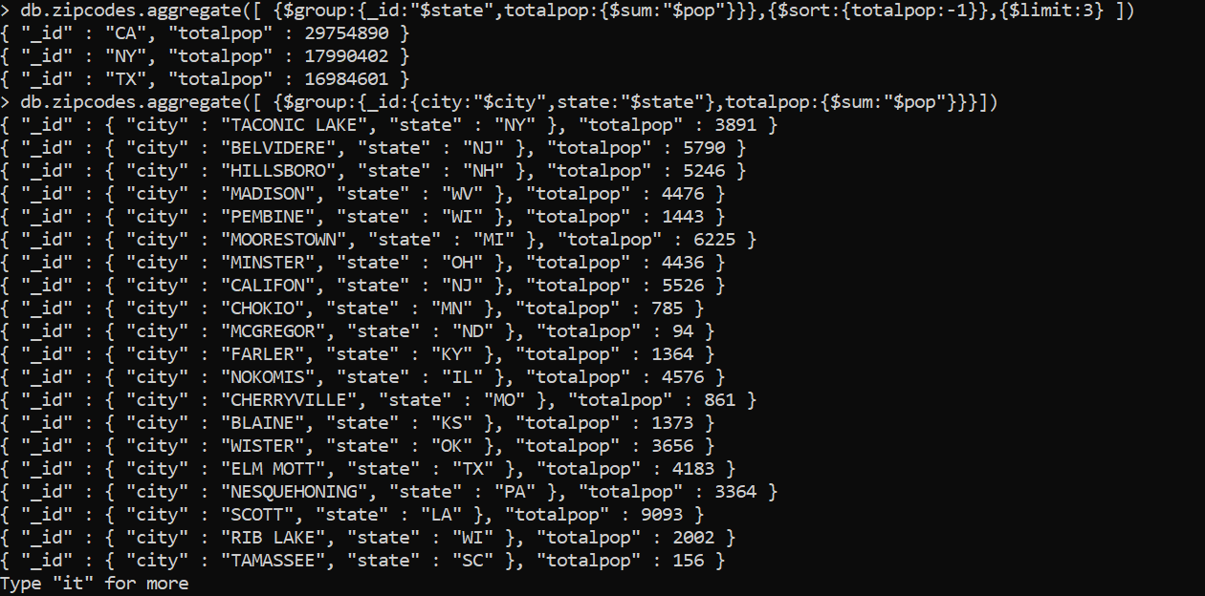

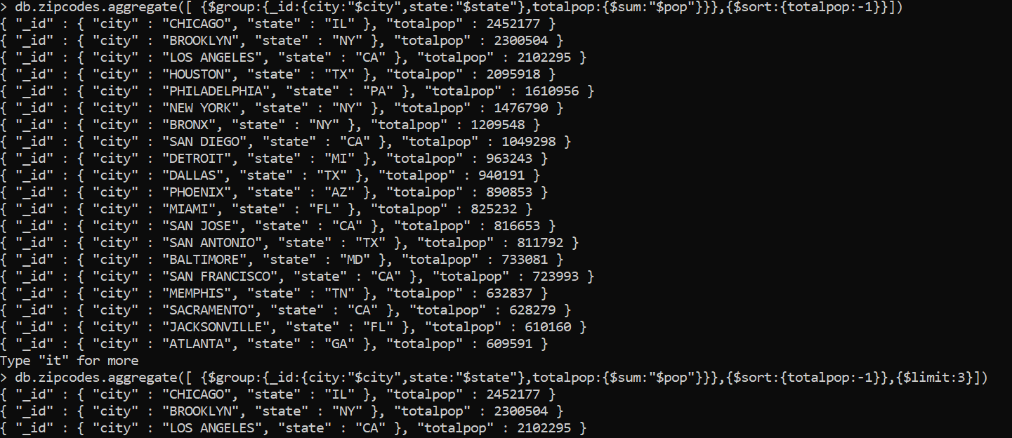

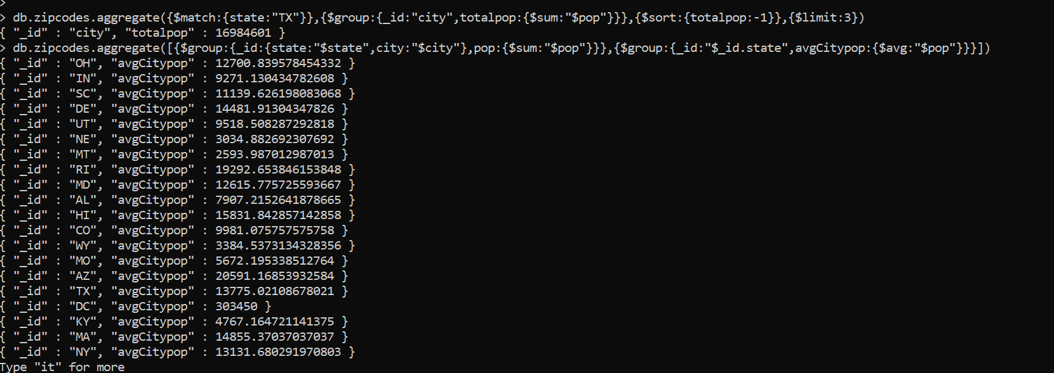



ASSIGNMENT 3

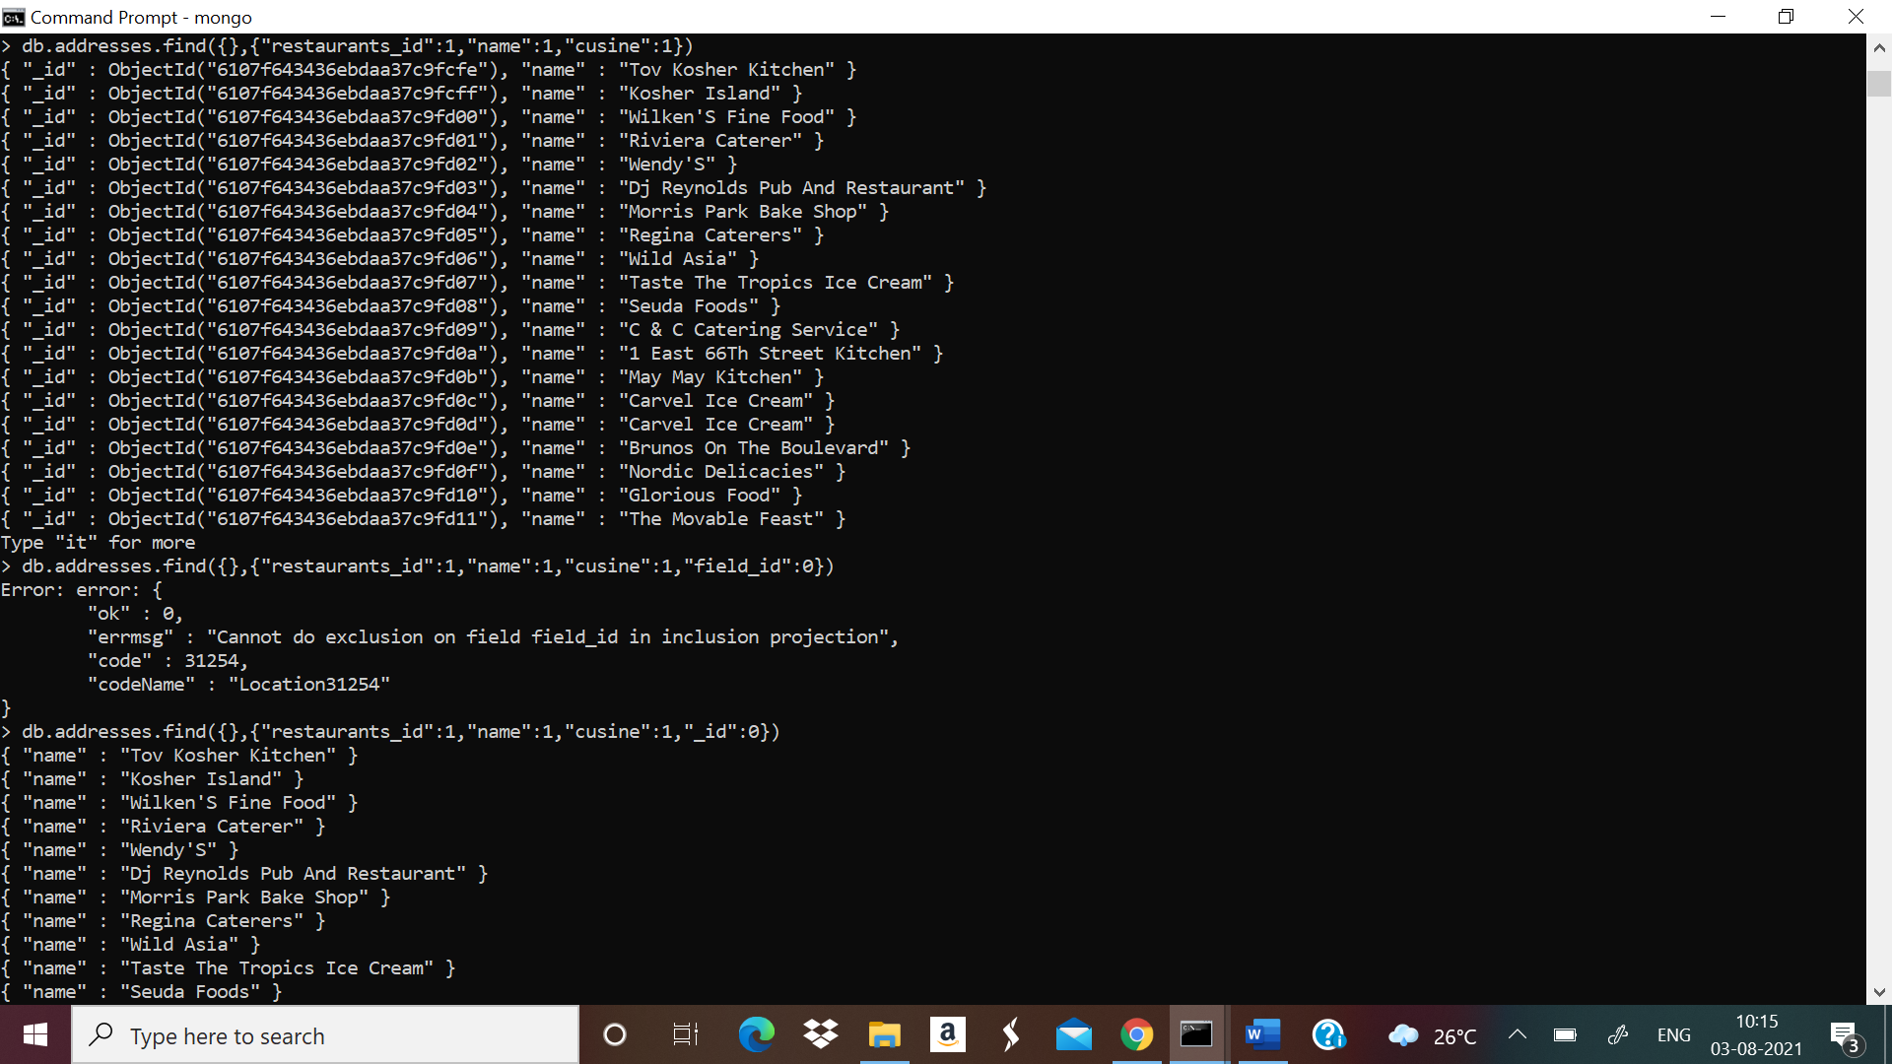

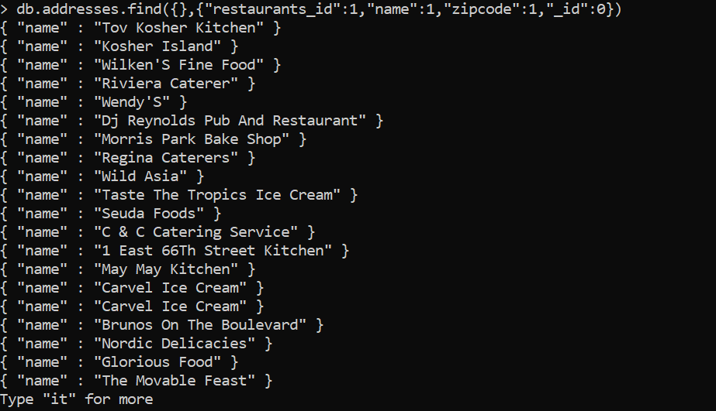

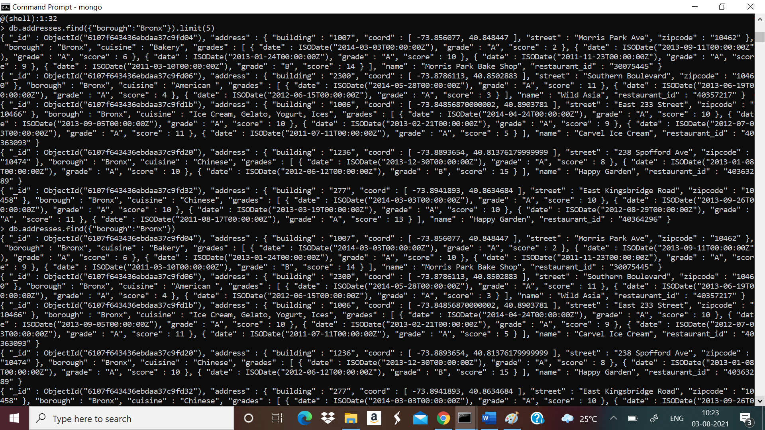

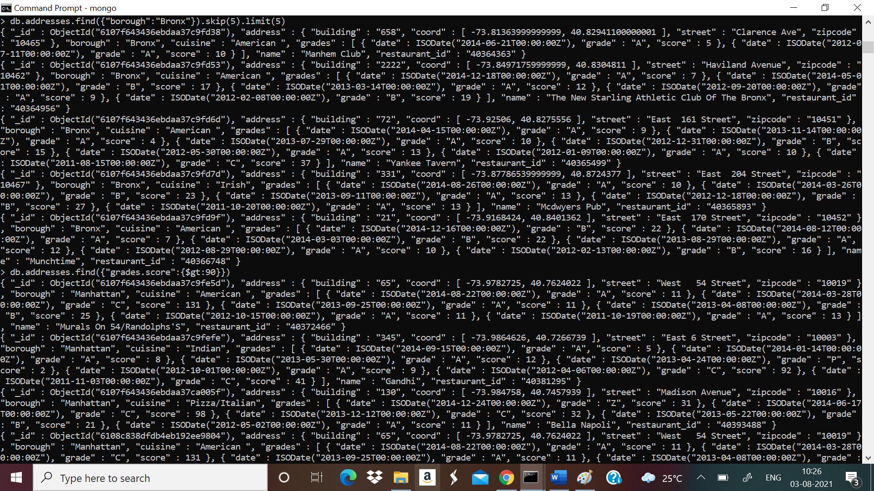

.db.addresses.find({"grades.score":{$gt : 80, $lt:100}})

10.db.addresses.find({"address.coord":{$lt:-95.754168}})

11.db.addresses.find({$and:[{"cuisine":{$ne:"American"}},{"grades.score":{$gt:70}},{"address.coord":{$lt:-65.754168}}]});

12.db.addresses.find({$and:[{"cuisine":{$ne:"American"}},{"grades.score":{$gt:70}},{"address.coord":{$lt:-65.754168}}]});

13.db.addresses.find({ $and:[ {"cuisine":{$ne:"American"}}, {"grades.grade":"A"}, {"borough" :{$ne: "Brooklyn"}} ] }).sort({"cuisine":-1});

14.db.addresses.find({“name”:/^Wil/},{"restaurant_id":1,"name":1,"borough":1,"cuisine":1})

15.db.addresses.find({“name”:/ces$/},{"restaurant_id":1,"name":1,"borough":1,"cuisine":1})

16.db.addresses.find({“name”:/.*Reg.*/},{"restaurant_id":1,"name":1,"borough":1,"cuisine":1})

17.db.addresses.find( { "borough" : "Bronx", $or: [{"cuisine" : "American "},{"cuisine" : "Chinese"} ] } )

18.db.addresses.find( {"borough" :{$in :["Staten Island","Queens","Bronx","Brooklyn"]}}, { "restaurant_id" : 1, "name":1,"borough":1, "cuisine" :1 } );

19.db.addresses.find( {"borough" :{$nin :["Staten Island","Queens","Bronx","Brooklyn"]}}, { "restaurant_id" : 1, "name":1,"borough":1, "cuisine" :1 } );

20. db.addresses.find( {"grades.score" : { $not: {$gt : 10} } }, { "restaurant_id" : 1, "name":1,"borough":1, "cuisine" :1 } );

21. db.addresses.find( {$or: [ {name: /^Wil/}, {"$and": [ {"cuisine" : {$ne :"American "}}, {"cuisine" : {$ne :"Chinees"}} ]} ]} ,{"restaurant_id" : 1,"name":1,"borough":1,"cuisine" :1} );

22. db.addresses.find( { "grades.date": ISODate("2014-08-11T00:00:00Z"), "grades.grade":"A" , "grades.score" : 11 }, {"restaurant_id" : 1,"name":1,"grades":1} );

23. db.addresses.find( { "grades.1.date": ISODate("2014-08-11T00:00:00Z"), "grades.1.grade":"A" , "grades.1.score" : 9 }, {"restaurant_id" : 1,"name":1,"grades":1} );

24. db.addresses.find( { "address.coord.1": {$gt : 42, $lte : 52} }, {"restaurant_id" : 1,"name":1,"address":1,"coord":1} );

25. db.addresses.find().sort({"name":1});

26. db.addresses.find().sort({"name":-1});

27. db.addresses.find().sort( {"cuisine":1,"borough" : -1,});

28. db.addresses.find( {"address.street" : { $exists : true } } );

29. db.addresses.find( {"address.coord" : {$type : 1} } );

30. db.addresses.find( {"grades.score" : {$mod : [7,0]} }, {"restaurant_id" : 1,"name":1,"grades":1} )

31. db.addresses.find( { name : { $regex : "mon.*"} }, { "name":1, "borough":1, "address.coord":1, "cuisine" :1 } )

32. db.addresses.find( { name : { $regex : /^Mad/ } }, { "name":1, "borough":1, "address.coord":1, "cuisine" :1 } )